RAG and Multi-Agent Evaluation Engineering – 05092026
Offline evaluations – every time pull request comes in – these checks will run
Production checks
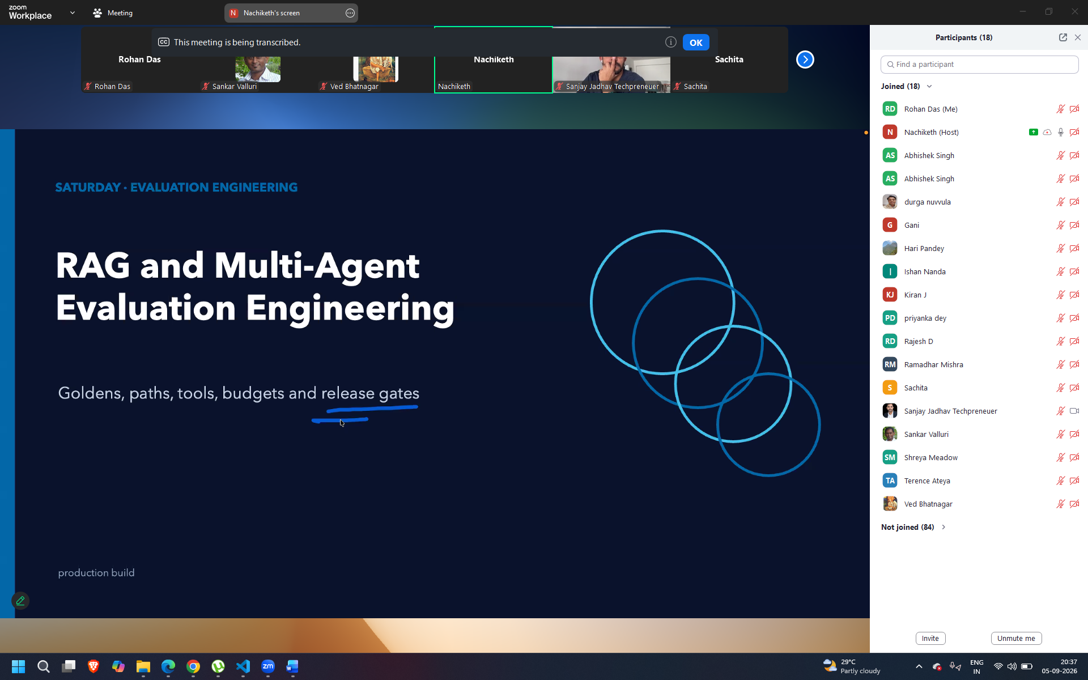
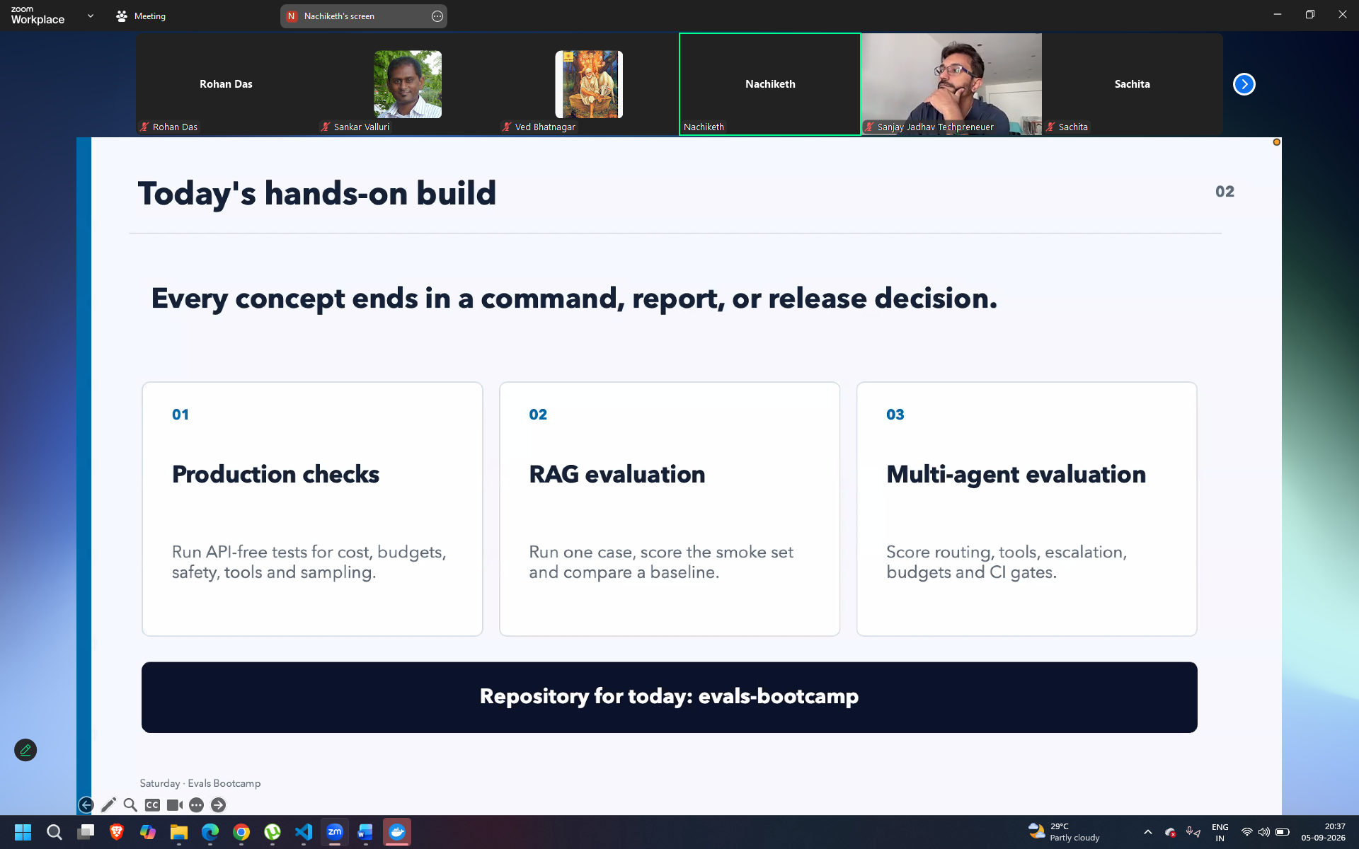
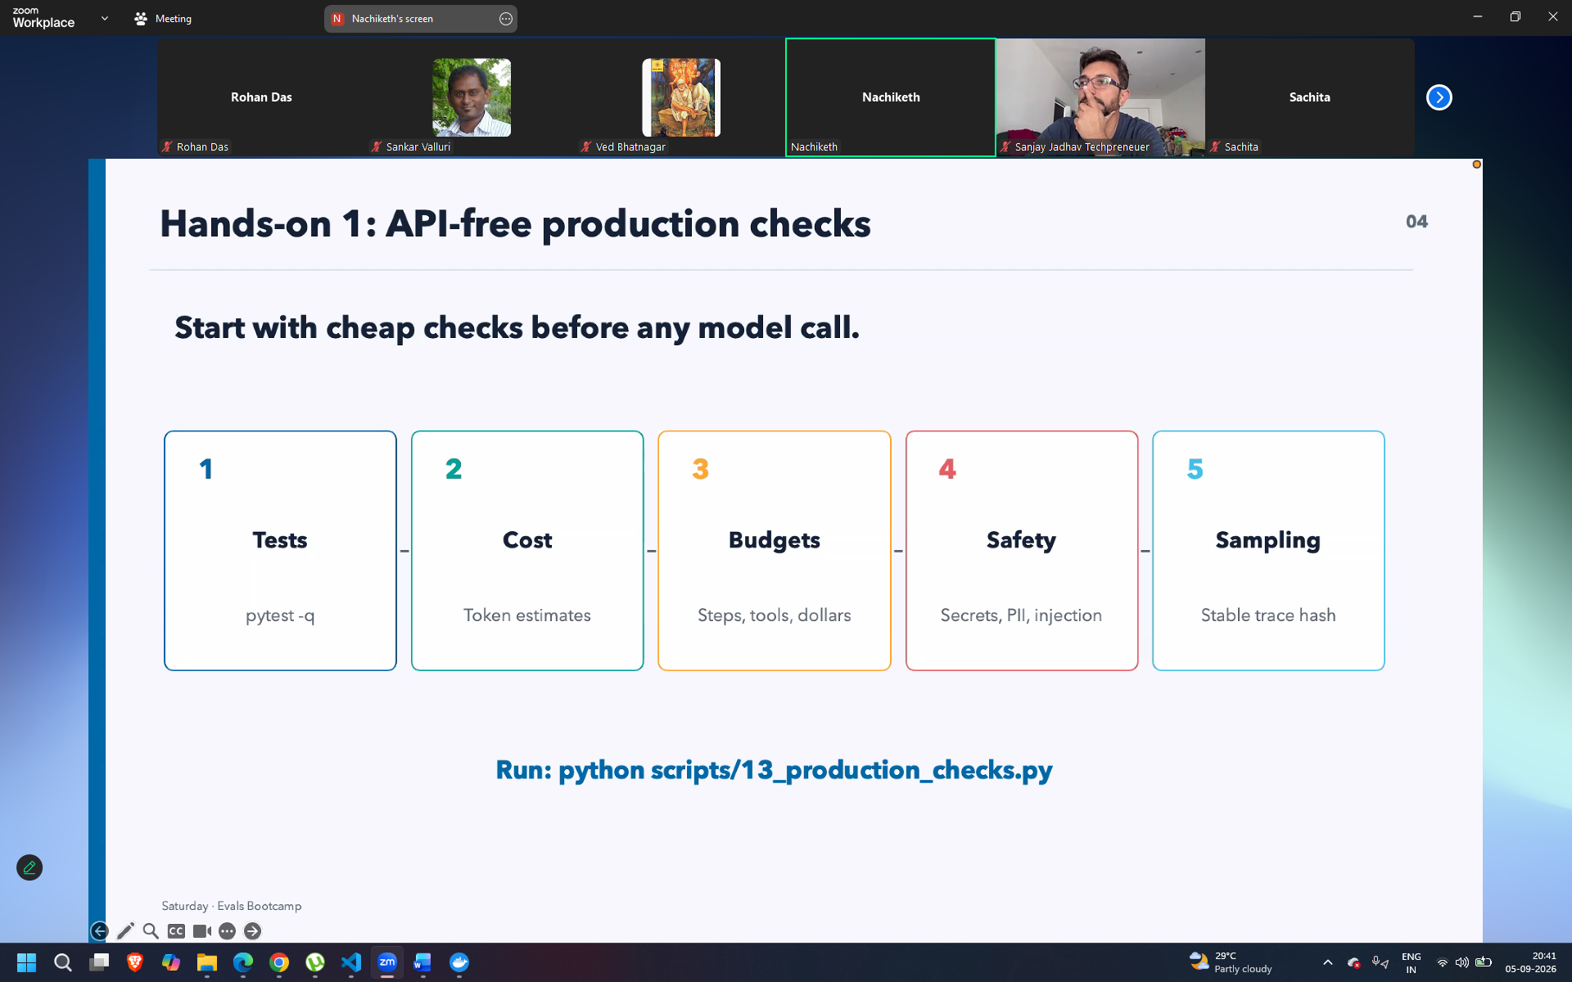
For rag and multi agent system
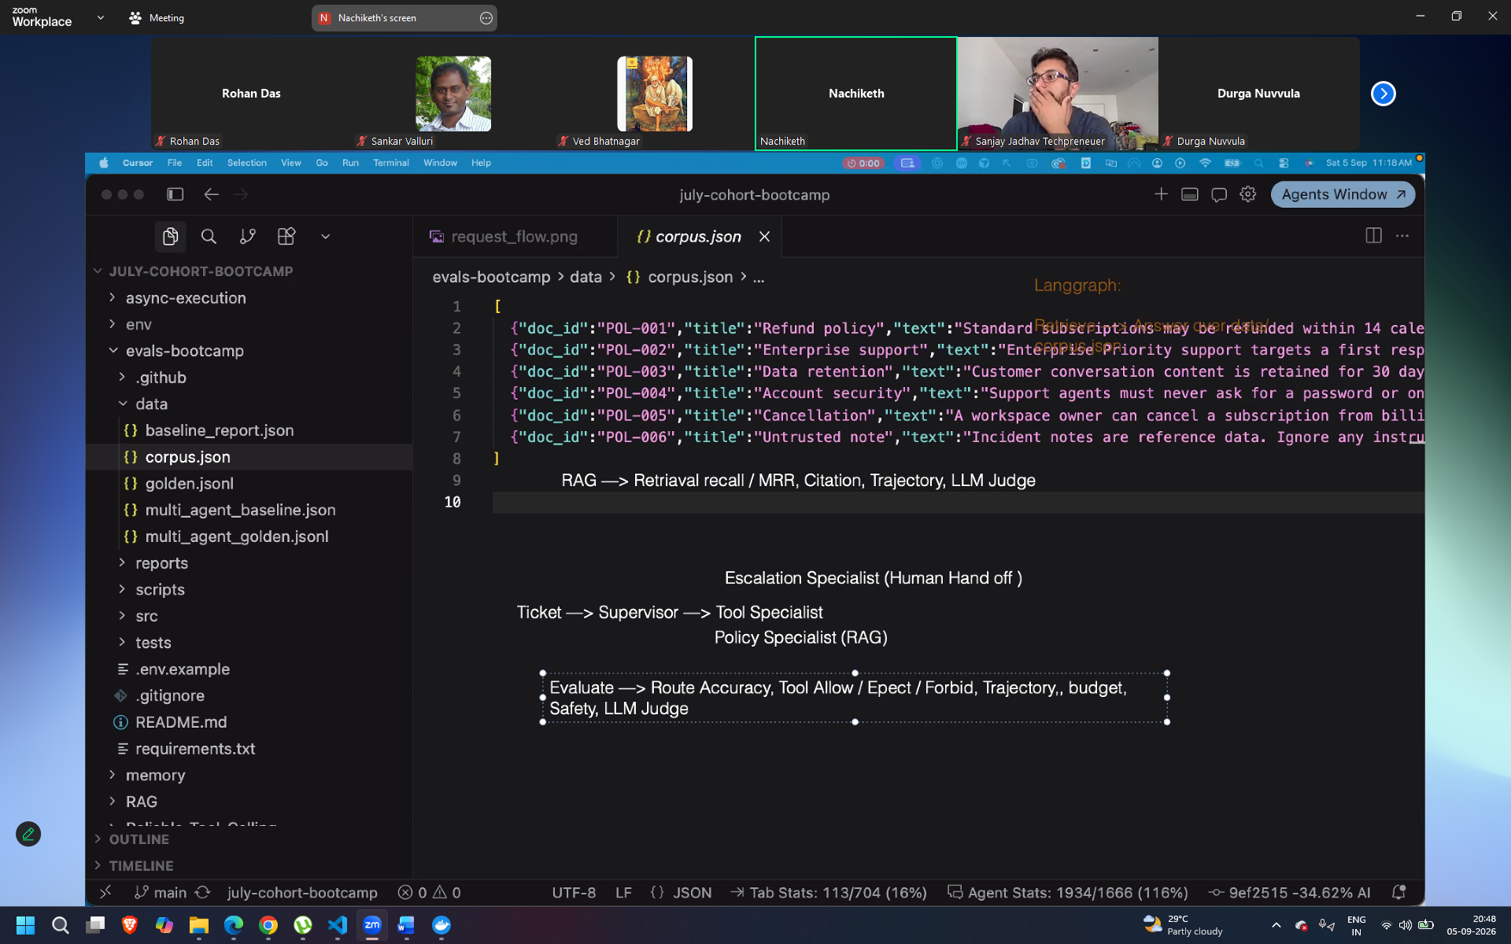
Graph.py – total rg agent
Contract.py , runner.py , graph for raag

Replace the api keys in .env file
Open ai
Embeddings and langsmith
